# Engineering Notes: setting up a Django Project on the BIT Platform

We ultimately want a directory of Python code and web templates to reside on gitlab.

* Clone your repo onto your local machine.
* Create a new directory in your local repo for this week’s work. Think of this as your **working directory**.
* Put at least one file in the new directory (e.g. a readme); add, commit, and push to gitlab.
* Bring up a command prompt inside your working directory (git-bash should work).
* Fire up PyCharm and create a new project, setting the following things on the new project creation screen (you may need to click on the little triangle beside “Project Interpreter”):

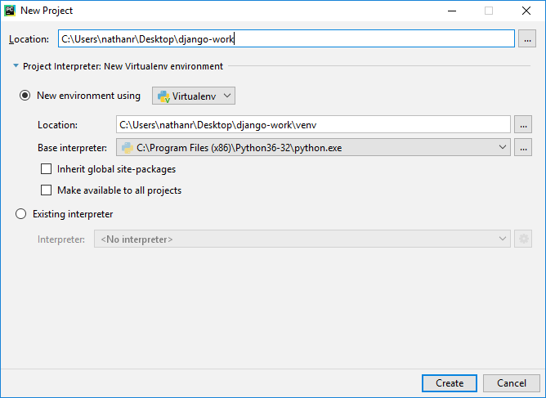

* Make sure that Location is set to your working directory (mine is django-work on the desktop, yours may be different).
* Make sure you set the base interpreter! (Not to anything Python 2-ish.)
* Go back to the command prompt, whose current directory should be the working directory
* Create a new project with the command

django-admin startproject mysite

This should create a directory structure with a bunch of python files in it. The directories should also appear in PyCharm’s project browser window.

* Change into the mysite directory – you should find a file there called manage.py
* Run the development server with the command  
  python manage.py runserver
* Manage.py may or may not produce output. By default, it sets your project to listen on port 8000, so you can see if it’s working by pointing a browser at  
  <http://127.0.0.1:8000/>
* Quit the web server with ctrl-c.
* Since you’ve added more files, you should git add, commit, push.
* From this point on, you can follow the Django tutorial:

<https://docs.djangoproject.com/en/2.0/intro/tutorial01/>

From the section “Creating the Polls App.”

* We’re going to get into the database part a little later, so just stop at the end of tutorial01 for now.
* **Try this:** create a new App that tells the user how long it is in days until either Queen’s Birthday, Halloween, or Boxing Day. Which holiday the user sees should be chosen randomly each time the user visits the site. This is a **stateless application** i.e. it doesn’t have to remember anything from session to session, or request to request.